Tars V2 – Assembly

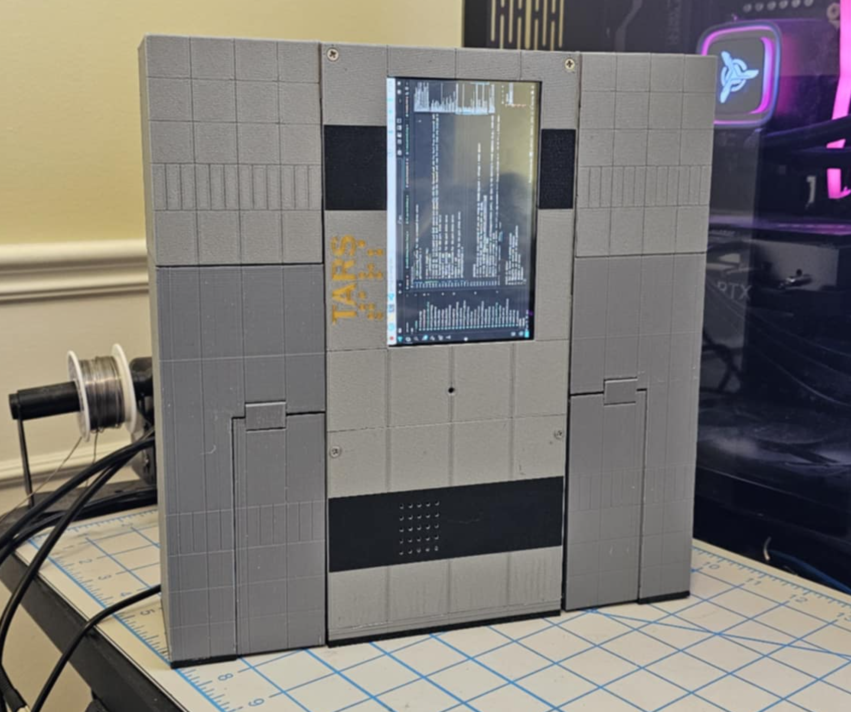

First install the active cooler on the raspberry pi.
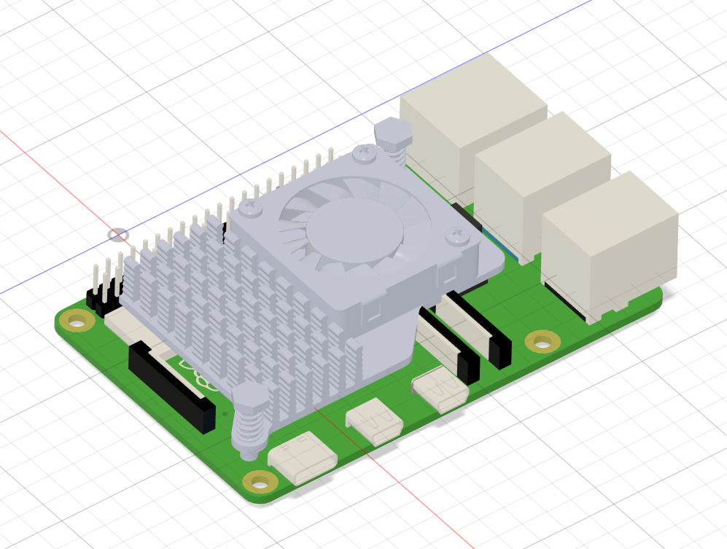

Stack the modules and plug the ribbon cable for the screen and camera. Notice how the ribbon cables are positioned. if you are using a ina260 to monitor the battery power, use the 3d printed supports to secure it
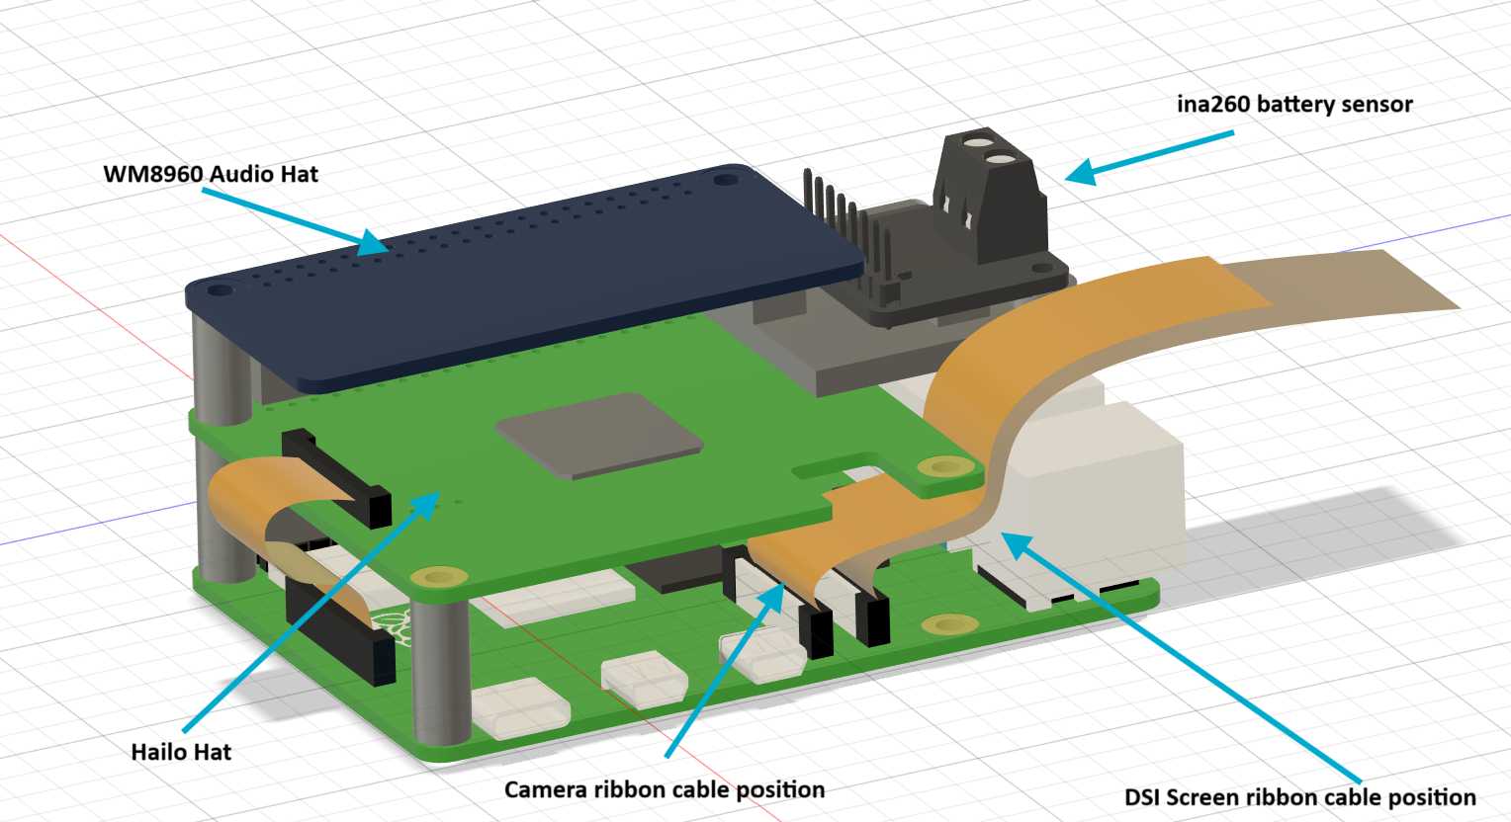
Install the drivers.

If you are using a Hailo module, add the extra long headers and stack the hailo module on top and connect the ribbon cable to the raspberry pi. You need to install the hailo libraries first.
sudo apt install hailo-all

Install the drivers for the Audio Hat
git clone https://github.com/waveshare/WM8960-Audio-HAT
cd WM8960-Audio-HAT
sudo ./install.sh
reboot your raspberry pi.
You should now see a the speaker and microphone controls.

Add the Screen config.txt configuration.
Open the config.txt file in the root directory of the TF card, add the following code at the end of the config.txt, save and safely eject the TF card.
dtoverlay=vc4-kms-v3d
dtoverlay=vc4-kms-dsi-waveshare-panel,7_0_inchC,dsi0

Add the heat inserts.
Make sure each heat insert is sitting flush to the part and the ones where the lid of the case screw need to be sitting below the lid parts. Each heat insert needs to be strait with the hole it is inserted into.

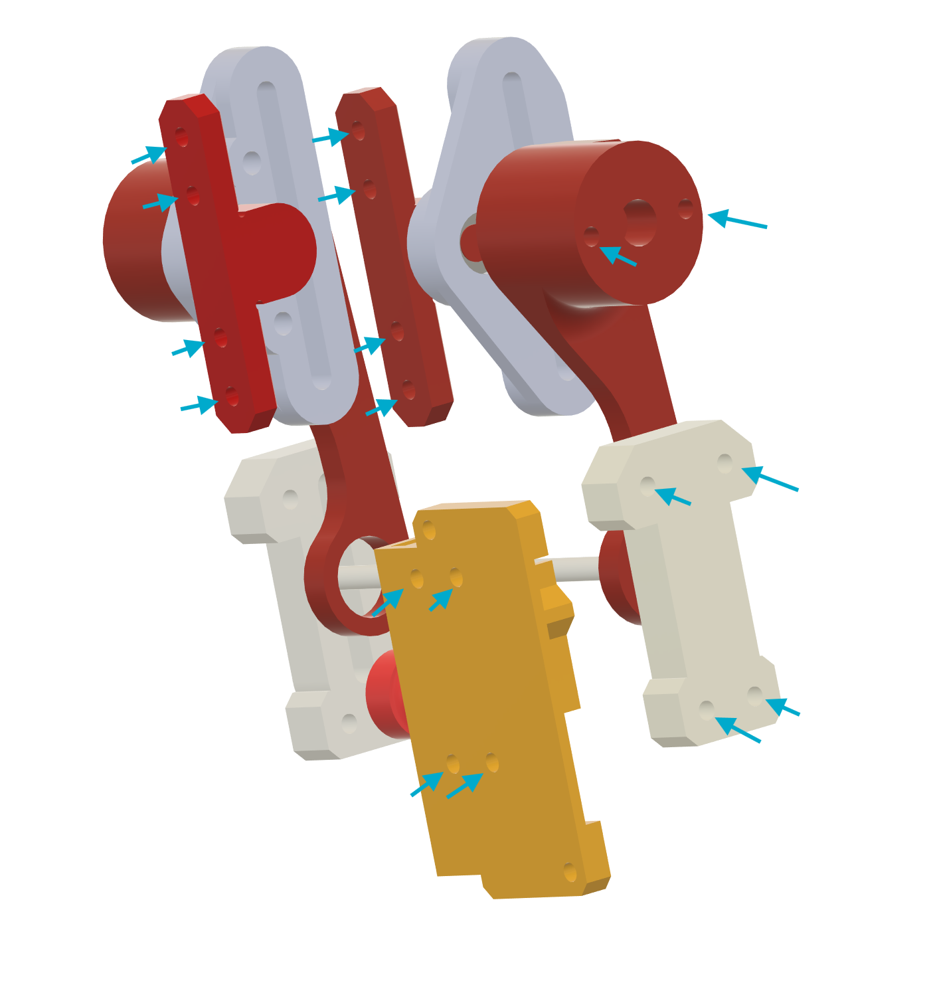

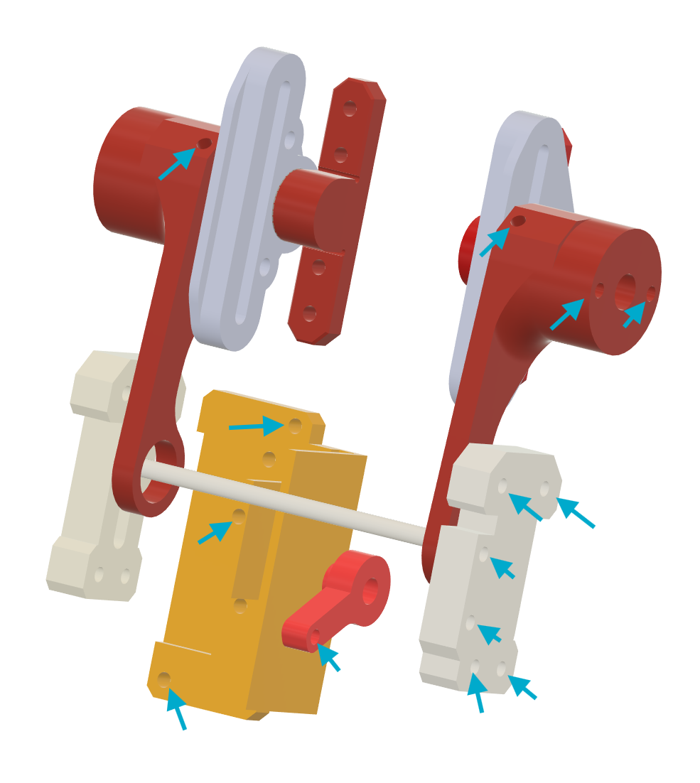

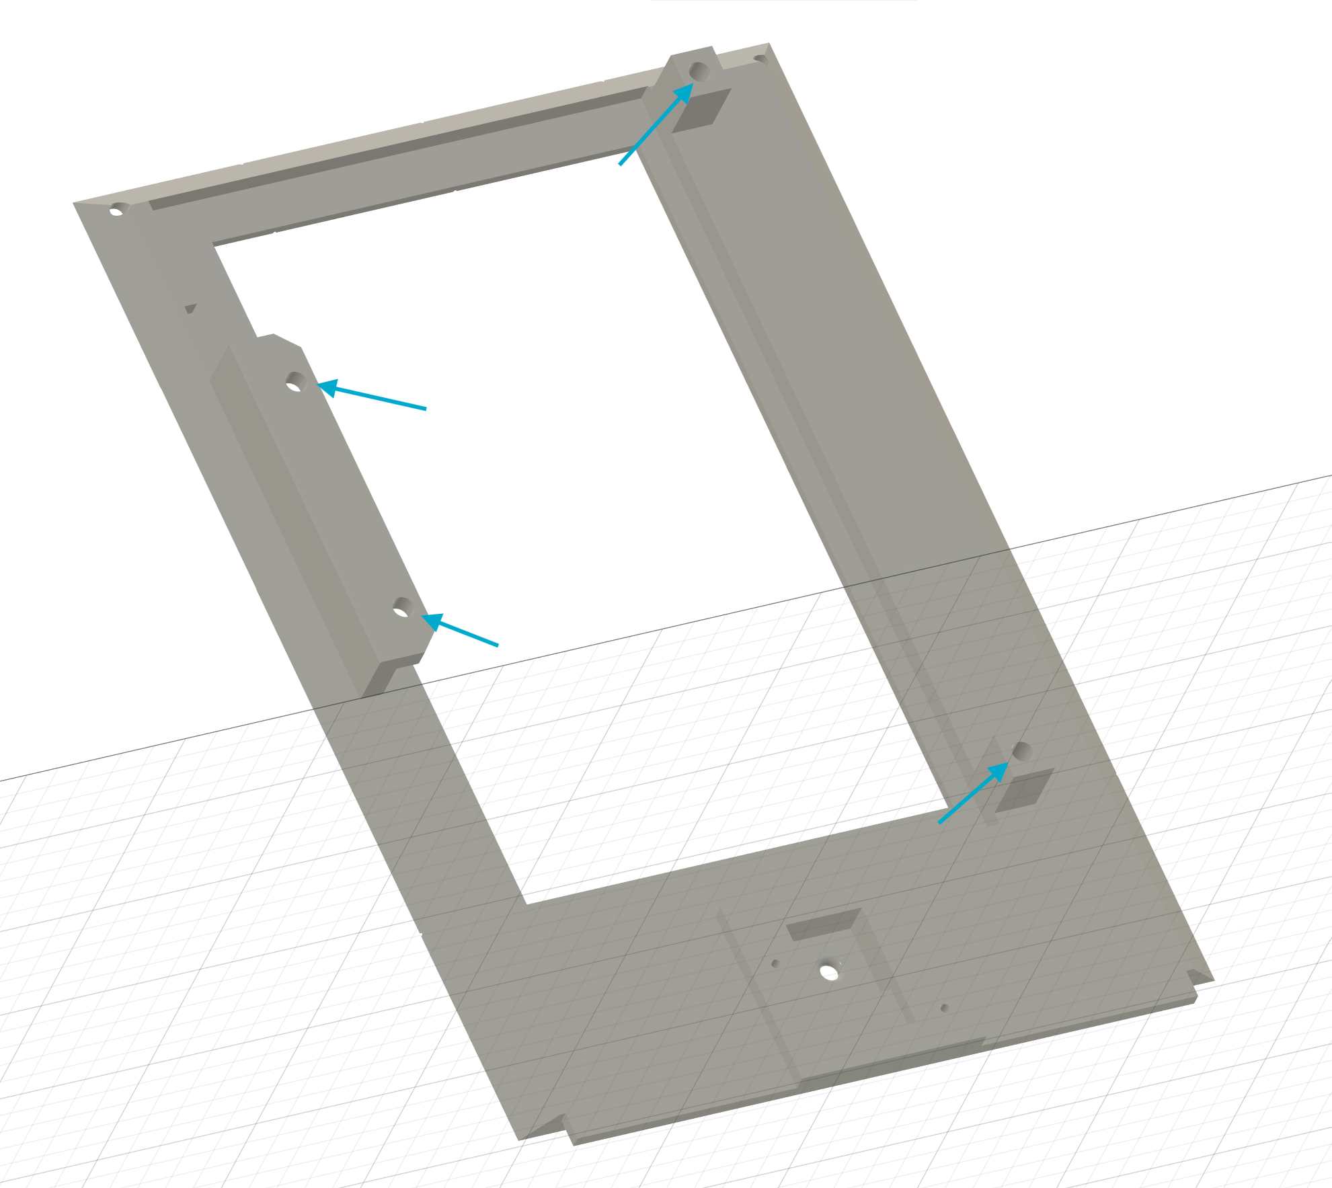

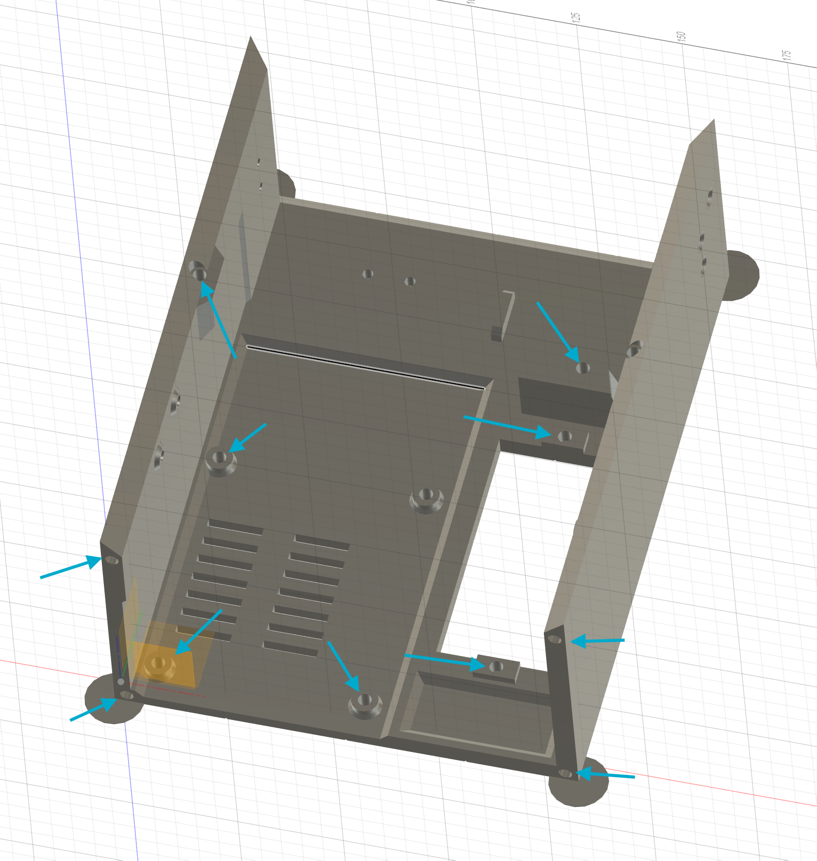

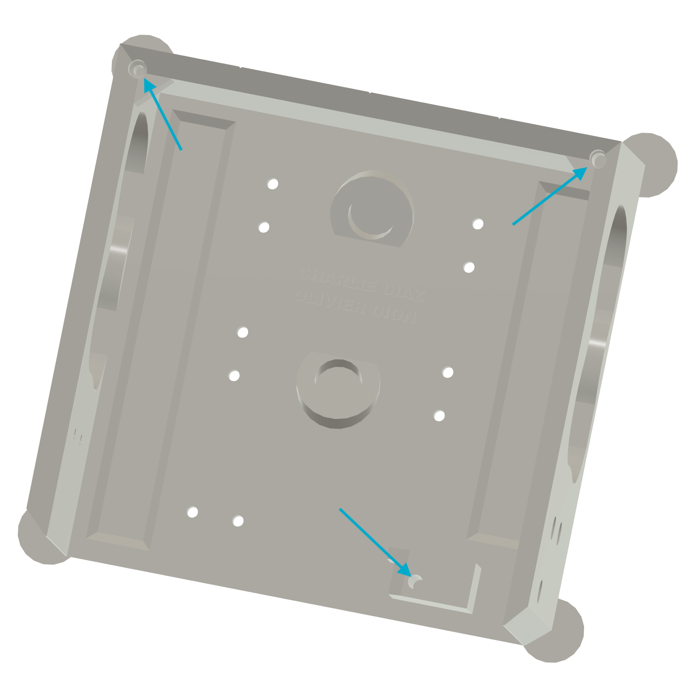

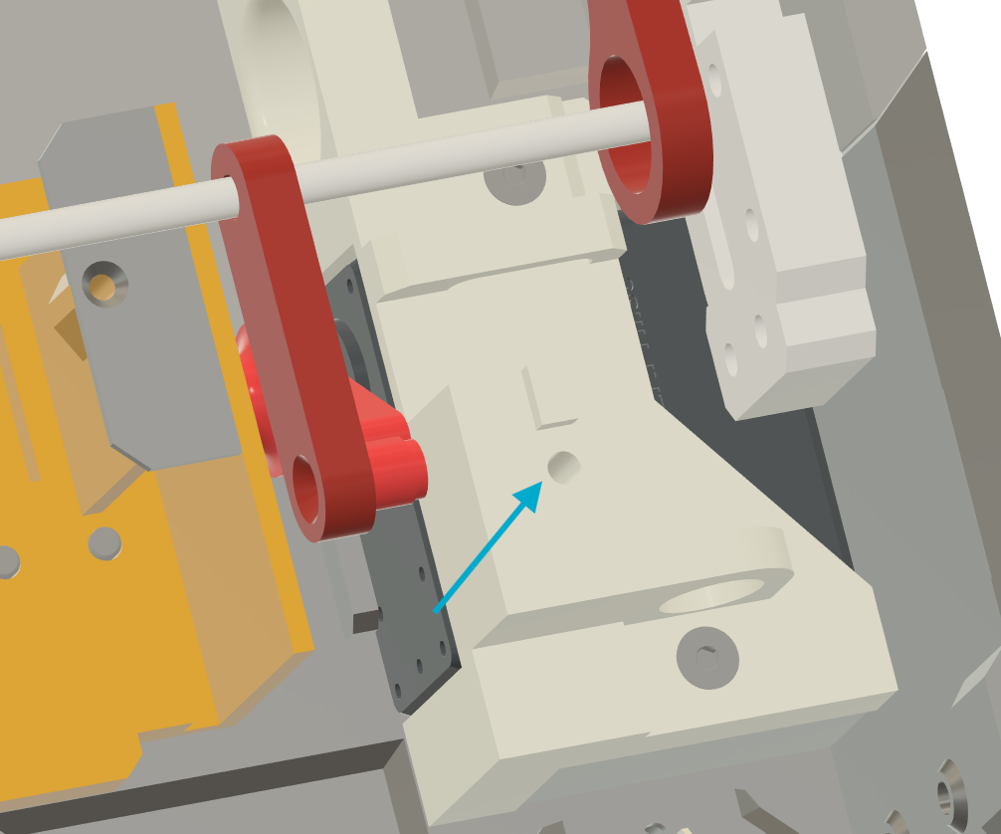

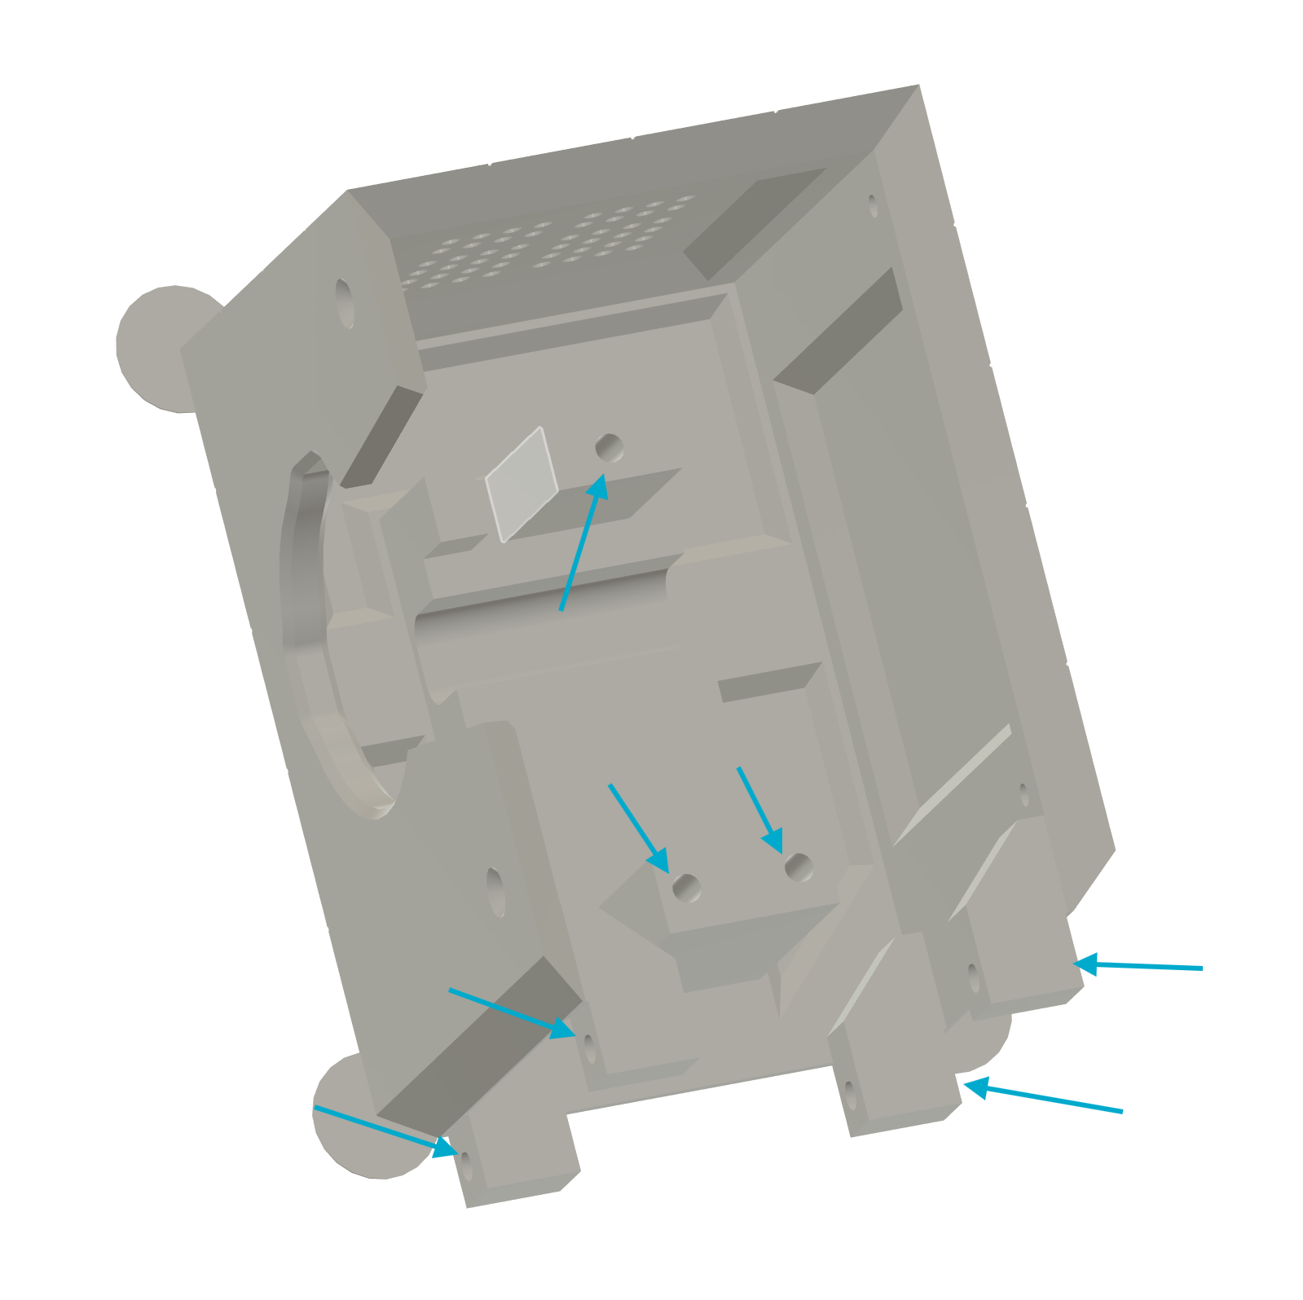
Both legs have the same holes, the left leg will have more holes for the buck converter than the right one.

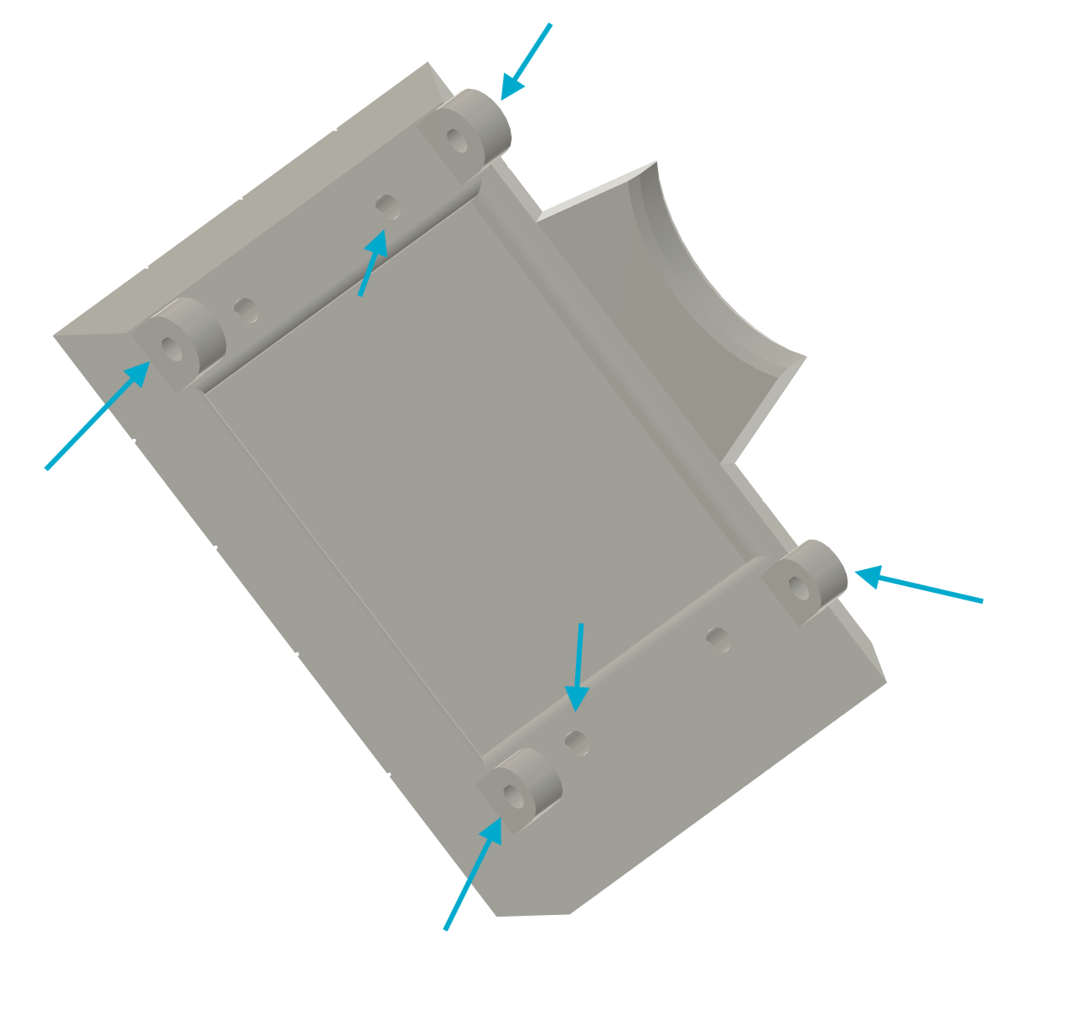

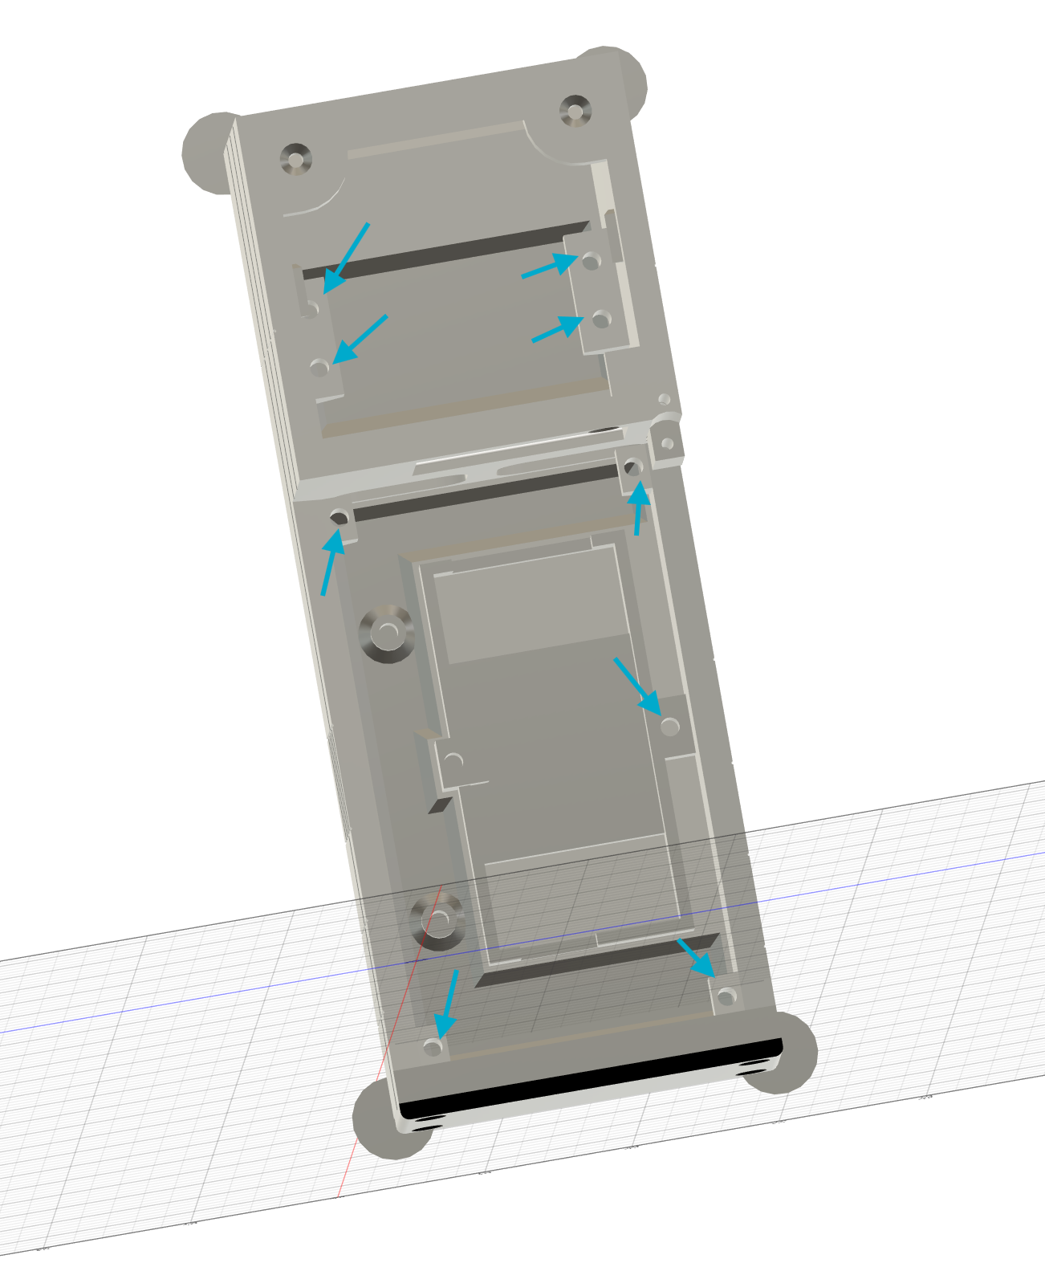

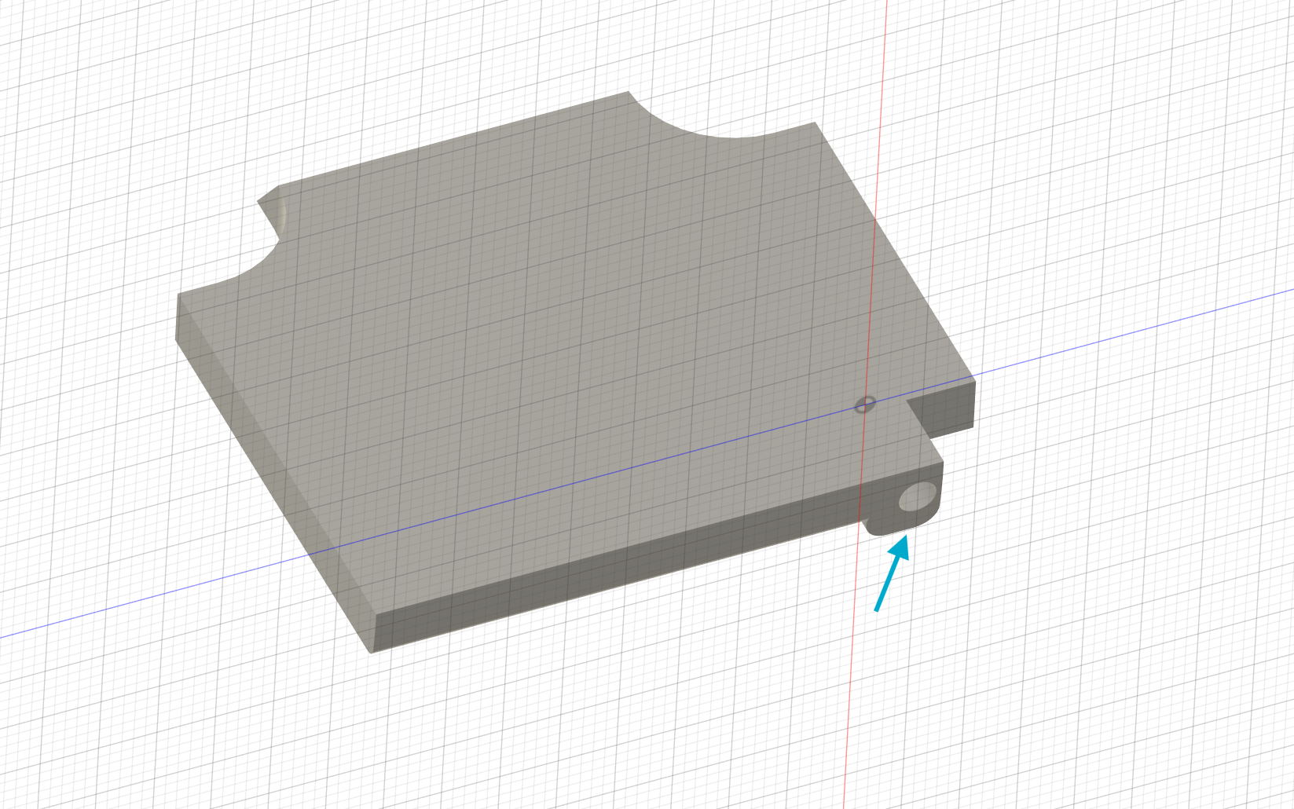

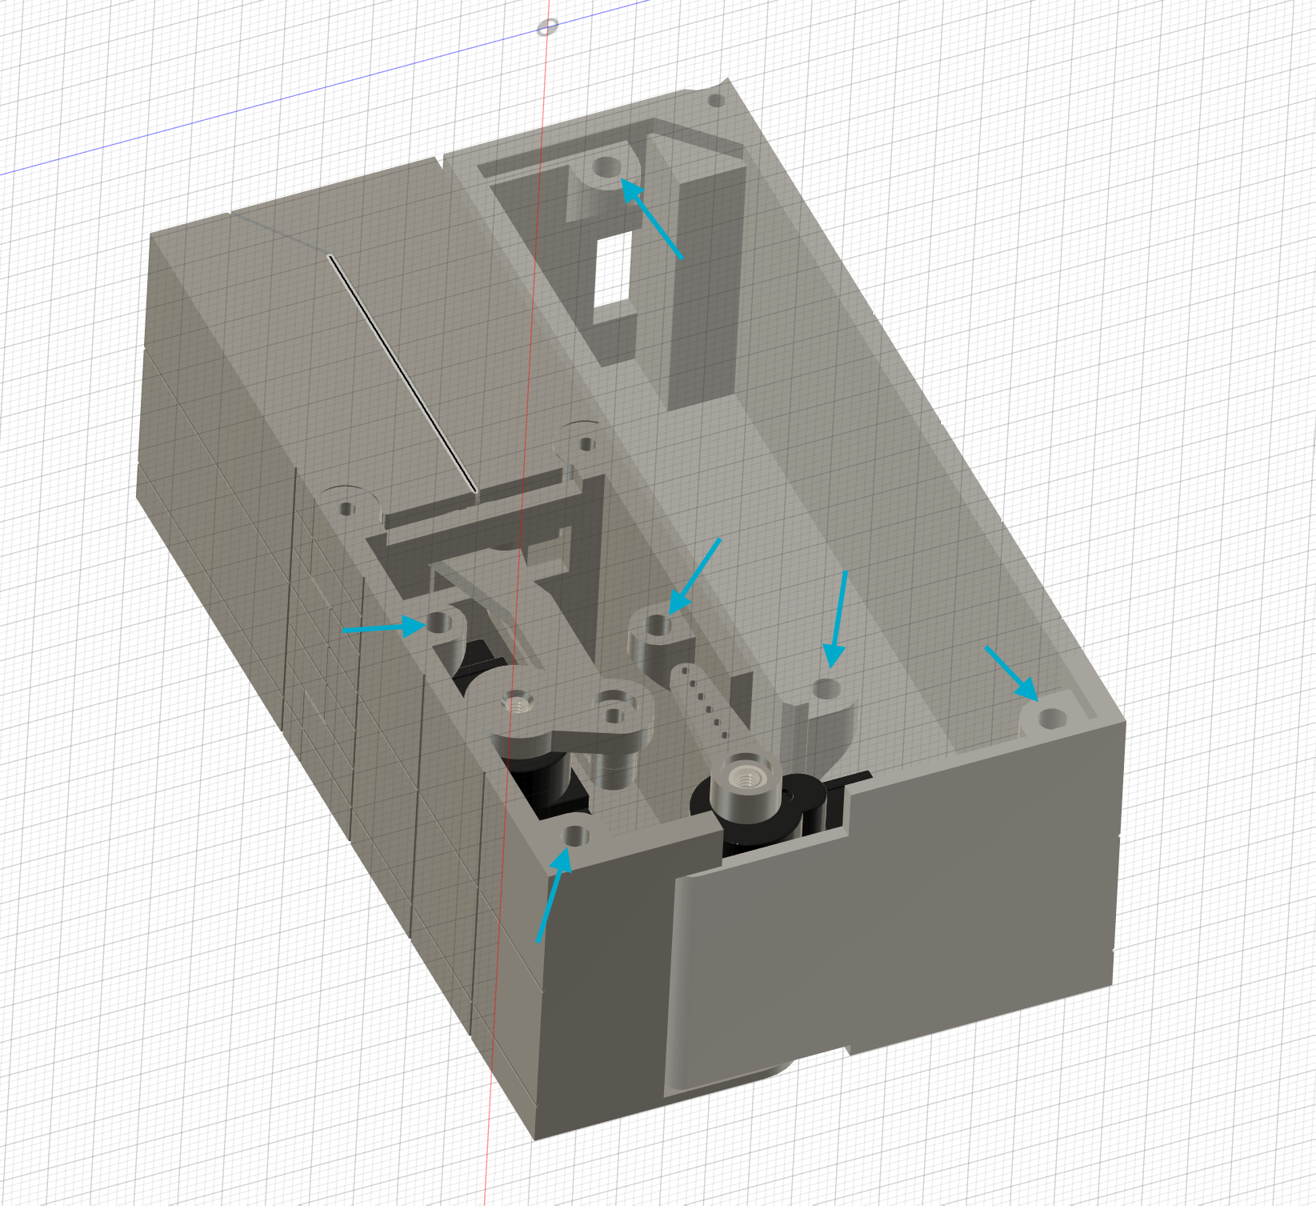

Parts modifications.

Cut the 4mm axel rods to these dimensions.

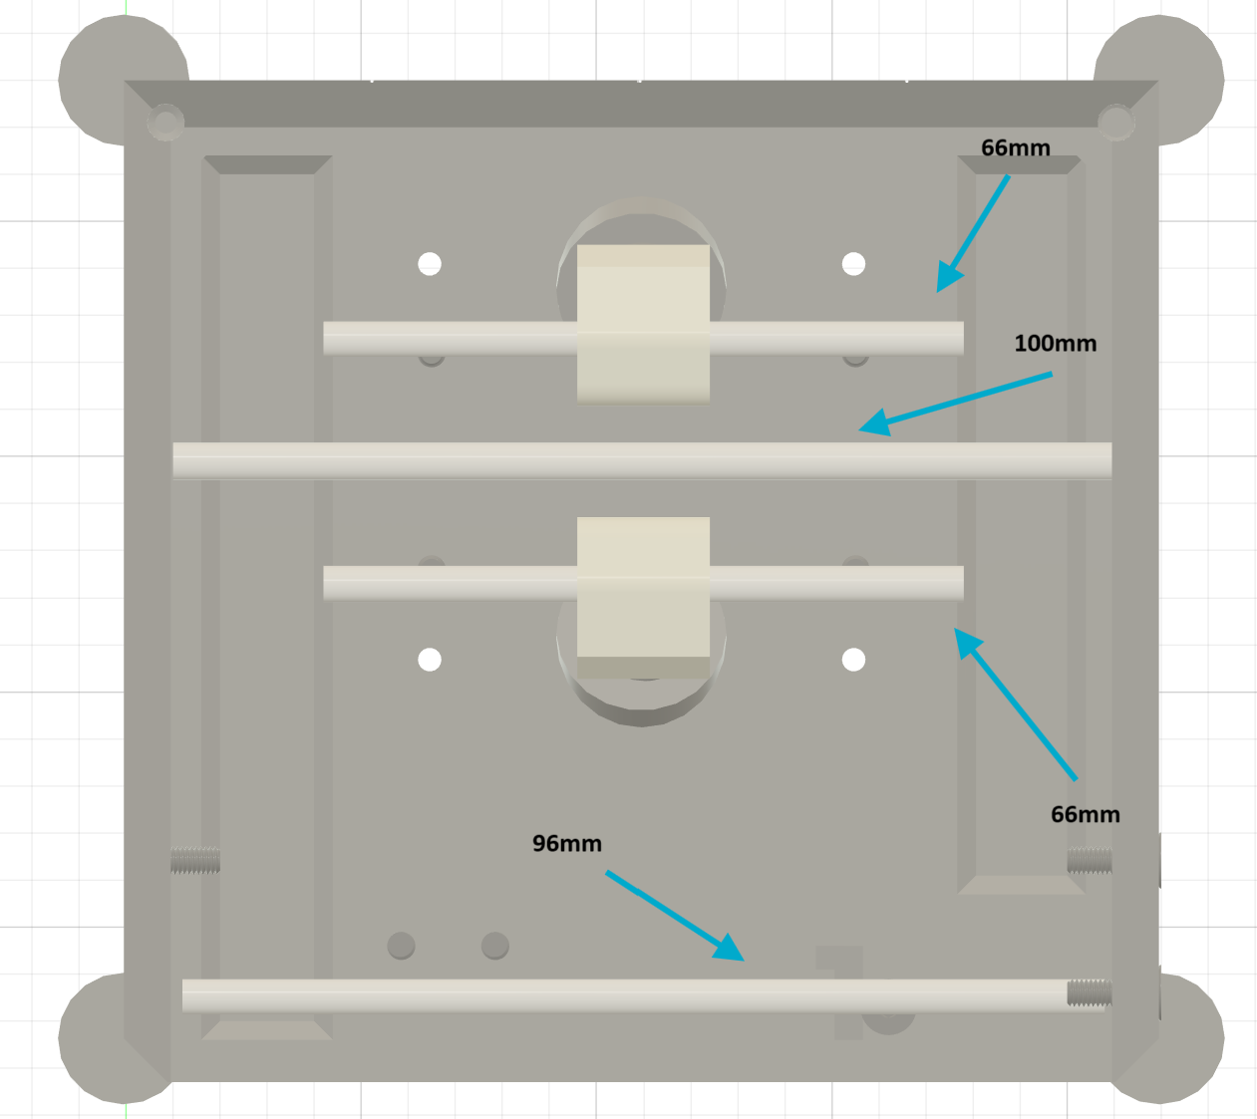

Cut the protruding plastic part on one of the LDX-227 servo if you are using them.

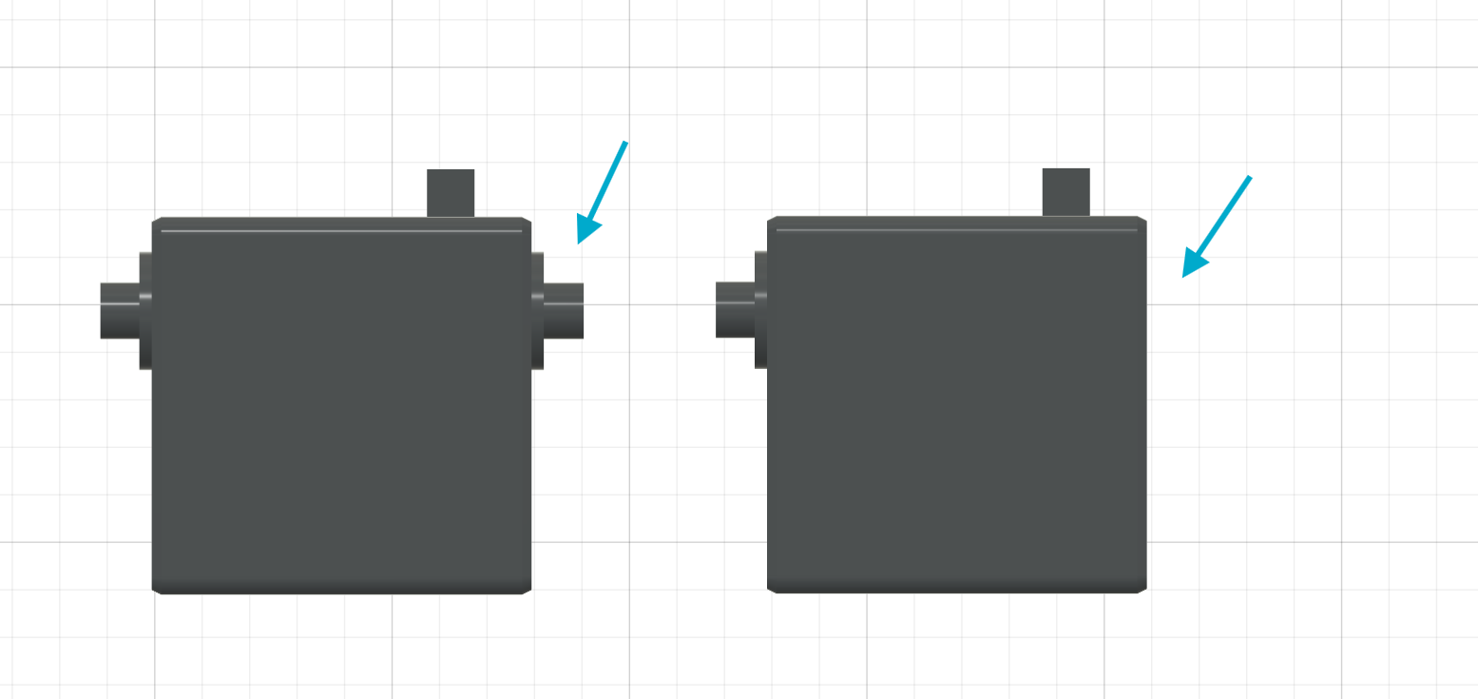

If the pins on your PCA9685 (servo controller) are bent, use some pliers to carefully make them strait.
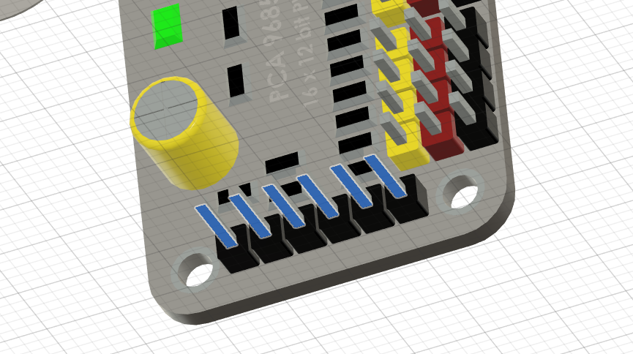

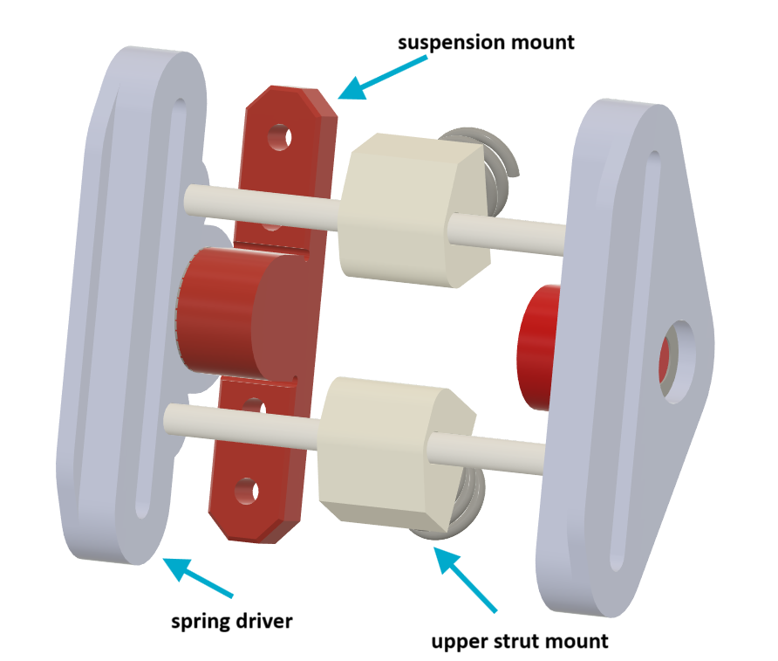

Assembly

Install the suspension :
1. insert the bearings in the left and right spring driver parts.
2. insert the strut mount parts on the 66mm axels
3. firmly push the axels on the spring driver parts
4. insert the suspension mount on the bearing on each side.
5. bolt the suspension on the upper case and make sure the springs are installed correctly.

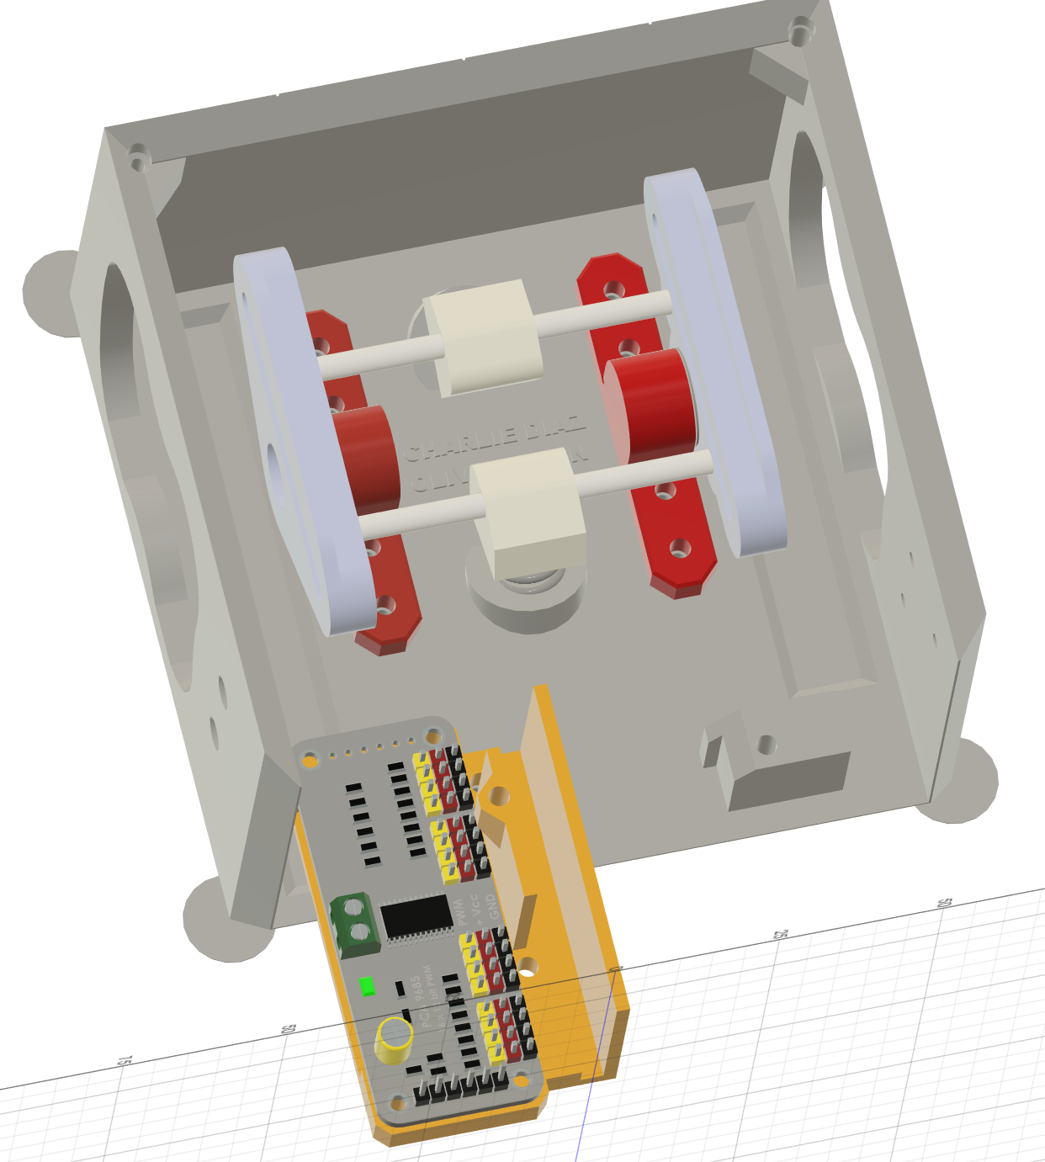
Bolt the pwm 12 channel servo support to the upper case and bolt the PCA9685 to the support.

Secure all the servo wires within the channel made for them and screw on the 12 channel pwm cap part to lock them in place.
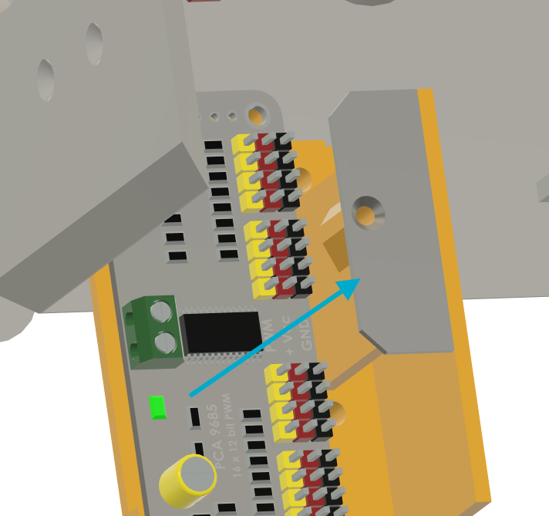

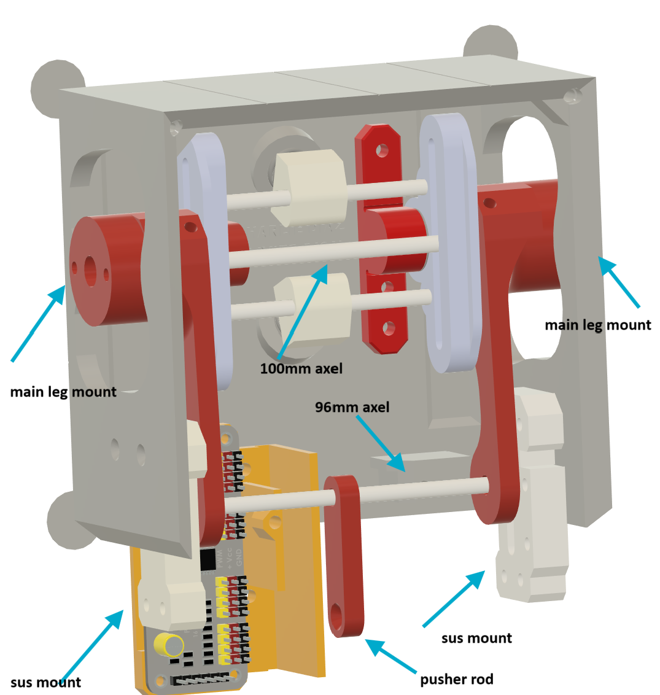
Slide the main leg mount on each side of the suspension and insert the 100mm axel in the middle. Secure each main leg mound and the axel using 1 screw for each. They must slide freely but not have too much play.

Once the main leg mounts are secured, drive the 96mm rod between the sus mount, pusher rod and main leg mounts but do not bolt the sus mount to the upper case just yet.

For this step, I strongly suggest color coding or identifying the extension cables to make it easier to reference later.

1. Connect 3 LDX-227 (or MR996R) servo on pin 0, 1, 2 of the servo controller. Connect the extension cables on pin 3,4,5,6,7,8

2. The servo for the left leg (pin 1) should have the wire go in the left hole of the upper case.

3. The servo for the right leg (pin 2) should have the wire go in the right hole of the upper case.

4. The extension cables on pin 3,4,5 should go in the left hole of the upper case.

5. The extension cables on pin 6,7,8 should go in the right hole of the upper case.

6. All the wires going through the upper case need to go below the suspension.

7. The remaining servo will be connected at a later step, we are only preparing the 3 main servo and wires at this step.

This is a reminded on what each servo controls:
#0 -Main Legs - Raise legs up and down
#1 -Left Leg Rotation
#2 -Right Leg Rotation
#3 -Right Leg Main Arm
#4 -Right Leg Forearm
#5 -Right Leg Hand
#6 -Left Leg Main Arm
#7 -Left Leg Forearm
#8 -Left Leg Hand

8. Cut 4 length of 50cm each of +/- 18 gauge wire, these are going to be the wires that will connect our buck converters and give us power. There is more length here than needed to give us more room to assemble everything.

9. 2 wires (+/- for each wire) go out from the upper case hole to the left leg and one will connect to the PCA9685 from the buck converter out (red) and one will connect the battery to the buck converter in (orange).

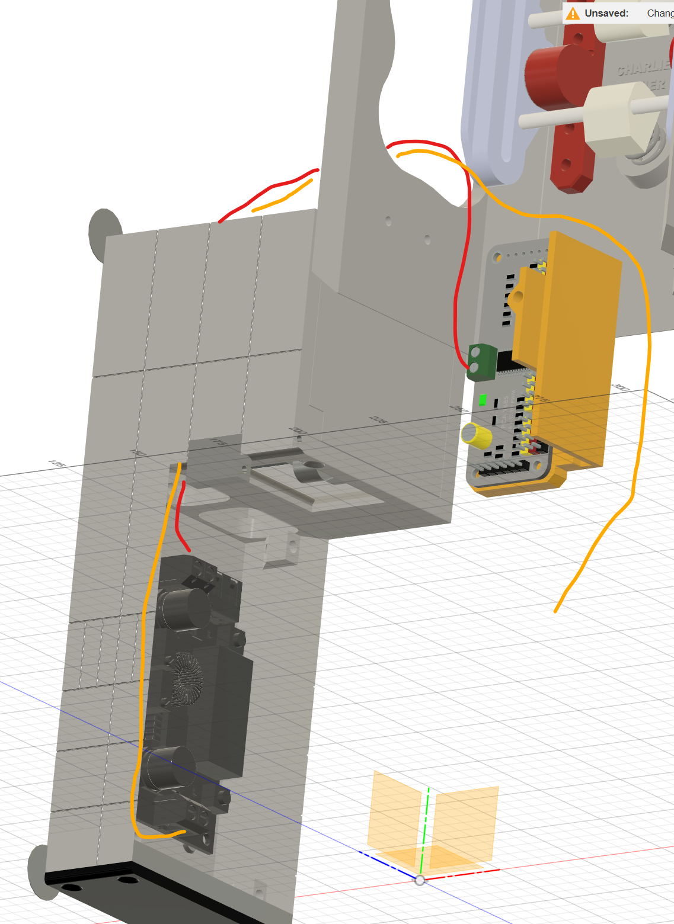

10. Do the same for the right leg with the buck converter for the raspberry pi.

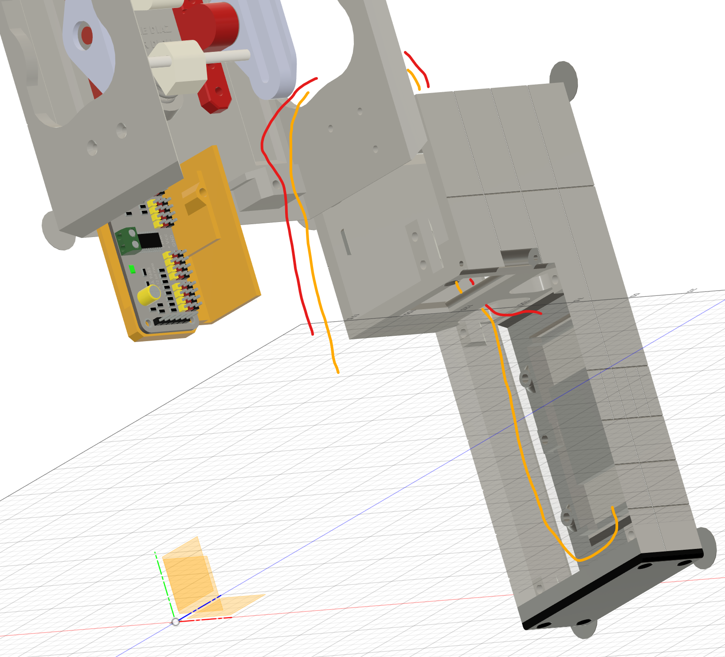

11. Solder the USB-C breakboard on the wire that provide the 5 volt from the buck converter (the out port of the buck converter) and respect the polarity (+/-)

12. Both wires that supply power to the buck converters can no be spliced together and plugged to the battery.

13. Adjust the buck converter for the servo so that it outputs 6V by turning the little screw.

Create the wire loom that connects the ina260 (if using one) and the PCA9685 following this diagram. If you are using an ina260, you must solder the A0 address in order to assing it another i2c address. Note that there is very little space so use only what is needed in wire length.
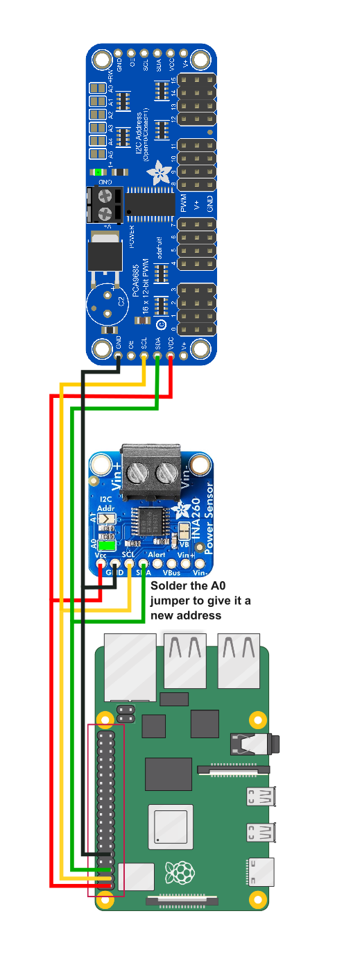

Setting the Main servos

1. Connect the Raspberry pi, PCA9685 (and ina260 if using)

2. Run the V2_app-servotester.py file.

3. Select the first option: 1. Set all servos to preset position

4. Your 3 servo should now all be in their center position. (avoid rotating them otherwise run that command again)

5. Position the printable servo horn on the servo that is plugged in pin0 so that it aligns like one this picture.

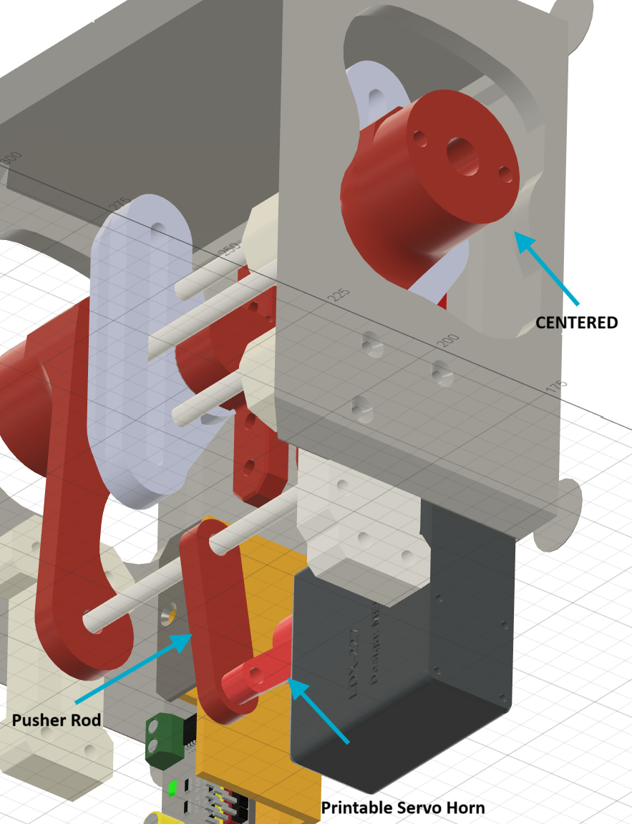

6. Secure the pusher rod and the printable servo horn with a 10mm screw. The pusher rod needs to rotate freely.

7. Slide the vertical servo mount over the servo and secure it with a screw on the upper case.

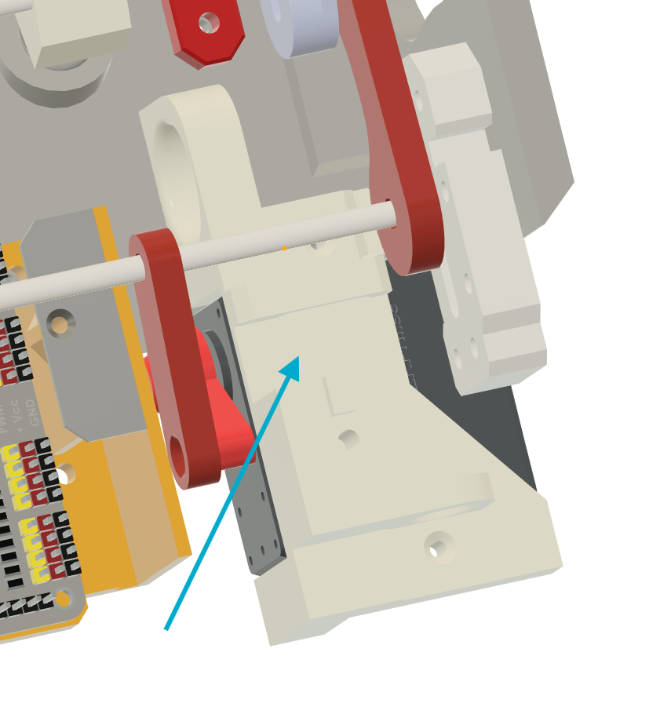

8. Bolt the sus mounts to the upper case.

9. Bolt the lower case to the sus mount, vertical servo mount and the 12 channel pwm support.

10. Bolt the vertical servo protector on top of the vertical servo mount.

Setting the Legs Servos

1. Add 2 12mm screw on each of the Right and Left Leg servo horn, place the horn so that it has the line on top. Secure the horn on each of the servo. If the servo rotated, run the V2_app-servotester.py script again so that you can center them back before putting the horn again.
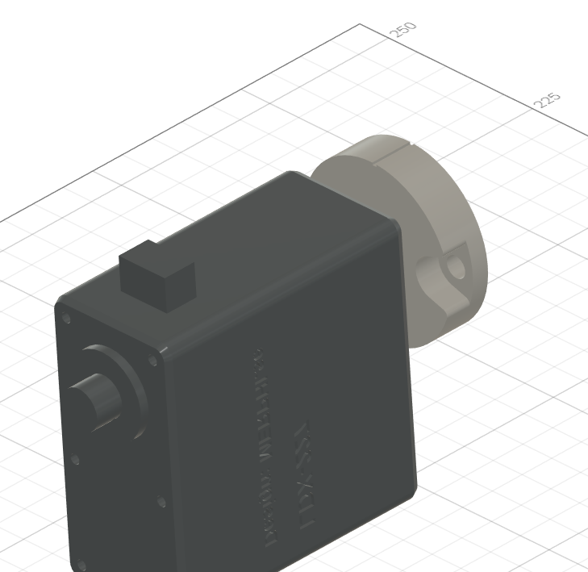

2. secure both servo horn on the main legs mount on each side.

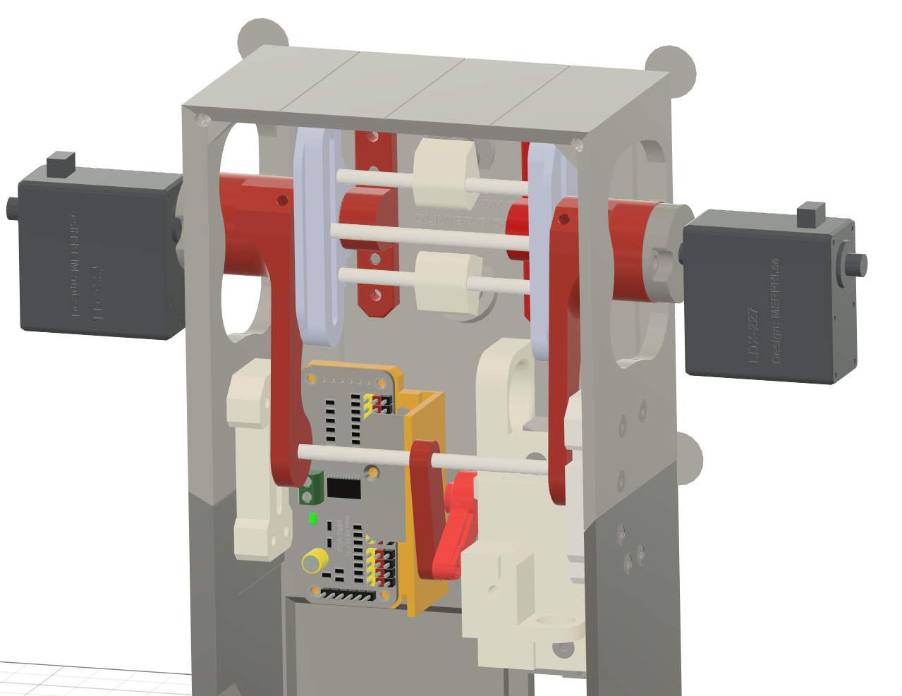

These next steps for the legs and arm are the same for each side, just mirrored.

Setting all the remaining servo to their positions.

1. Connect the remaining servos types to their respective extention wires

pin3 -Right Leg Main Arm - MG996R
pin4 -Right Leg Forearm - mg90s
pin5 -Right Leg Hand - mg90s
pin6 -Left Leg Main Arm - MG996R
pin7 -Left Leg Forearm - mg90s
pin8 -Left Leg Hand - mg90s

2. Run the V2_app-servotester.py and choose the first option again to set all the servo positions.

3. You can disconnect the servo again but make sure you remember which one goes on which wire.

Arms:

1. Install the 1 mg90s servo to the main arm case and secure it using the self tapping screws that come with it.

2. Feed the wire through the hole indicated by the arrow.

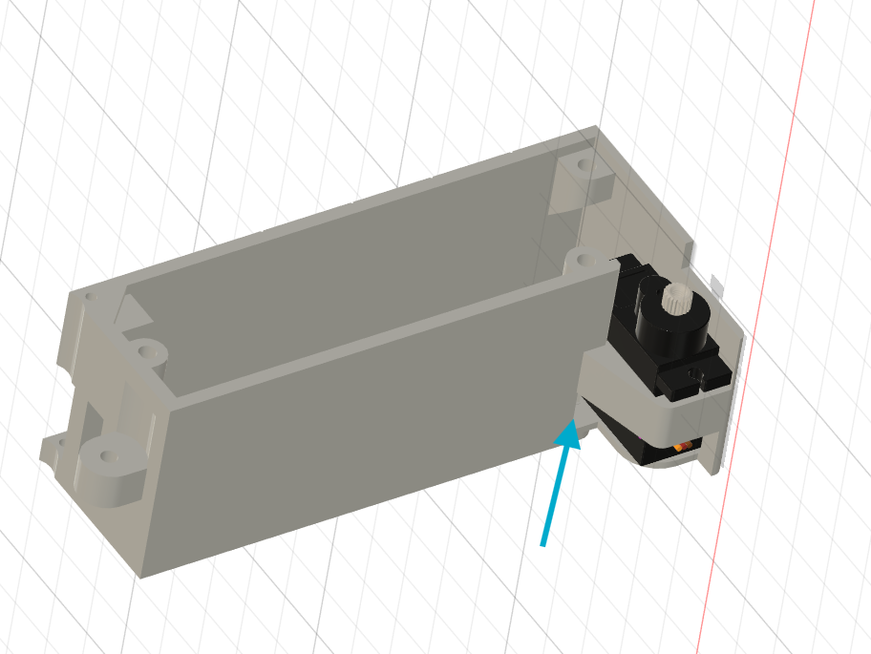

3. Pull the wire out from the top hole.

4. Run a length of filament through the hole that links the connector hinge and the main arm case. Cut the filament so it sits flush on each side.

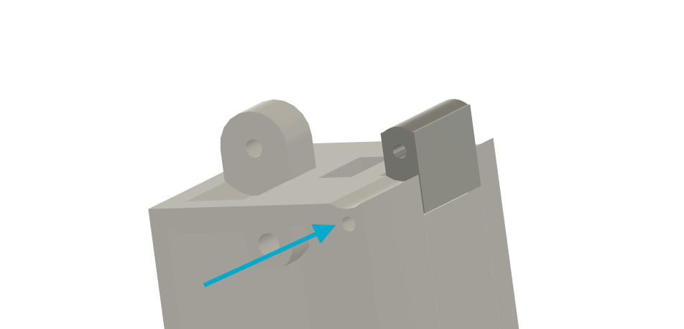

5. Install a mg90s servo in the forearm case. Use the self tapping screws that came with it. run the wire through the same hole as in step 2 and 3.

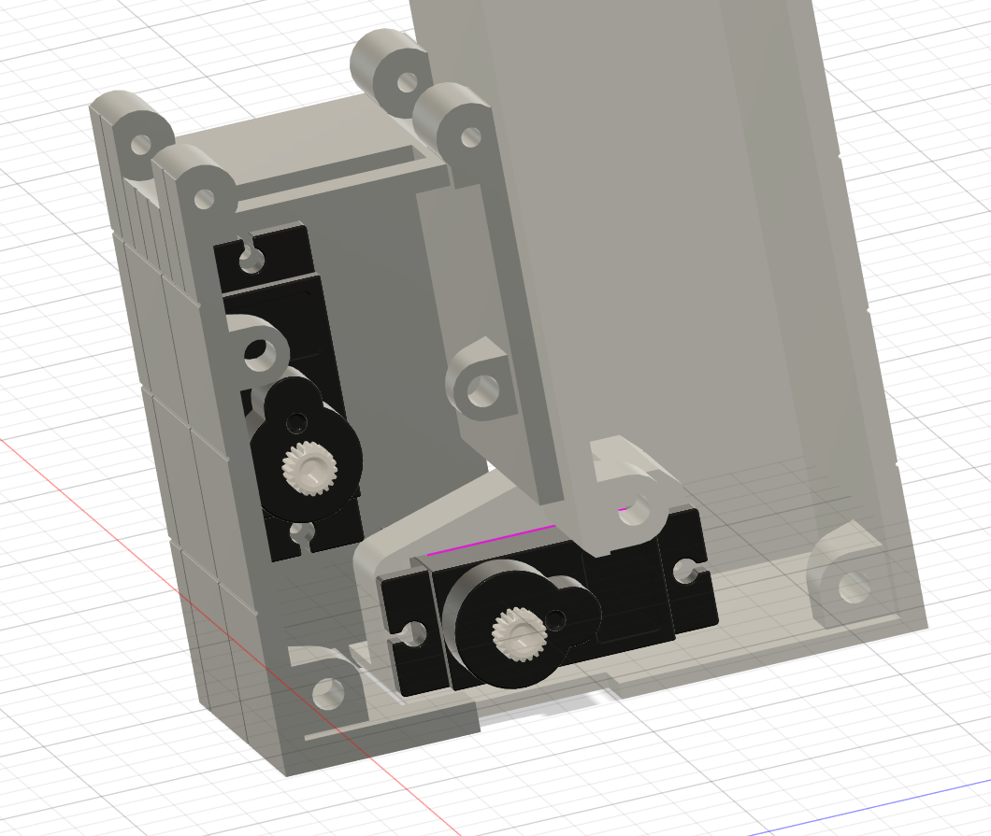

6. Bolt down the arm leg thing lid part to close the space where the buck converter is located.

7. Add one of the magnets in the Finger2 part. Put the finger plug in the hole to close it.

8. Add one magnet in the arm leg thing part with the polarity set to attrack the finger2 part to the arm leg thing part.

9. Use self tapping screws to connect the finger 1 and 2 rods. Finger2 rod is shown here in blue.
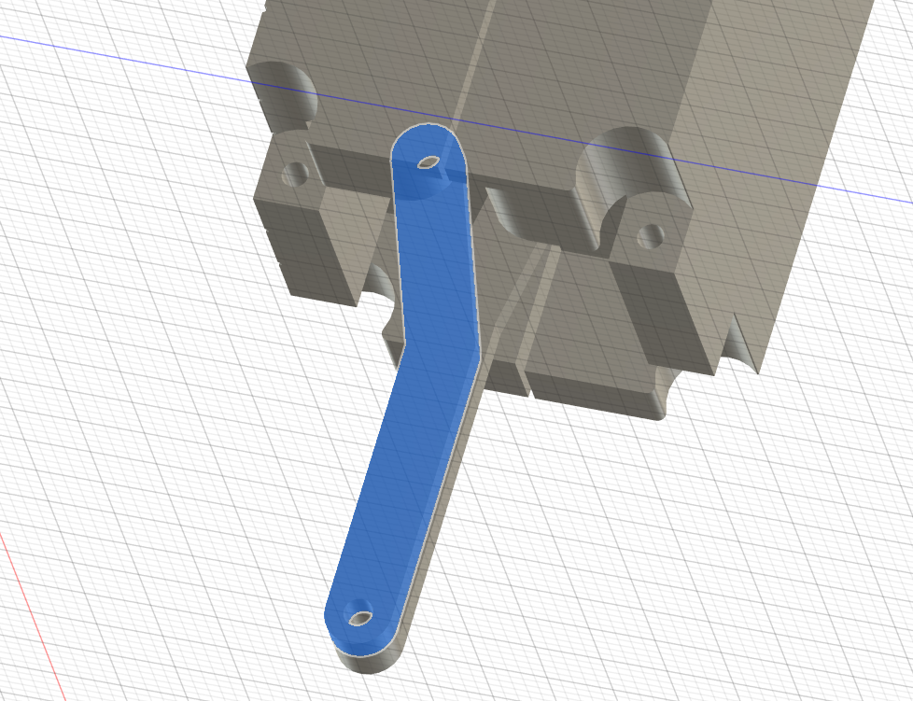

10. Insert the fingers in the forearm case and run a length of filament on each side of the holes indicated by these arrows. Make sure the filament runs the full lengh of the holes and sit flush on both sides.

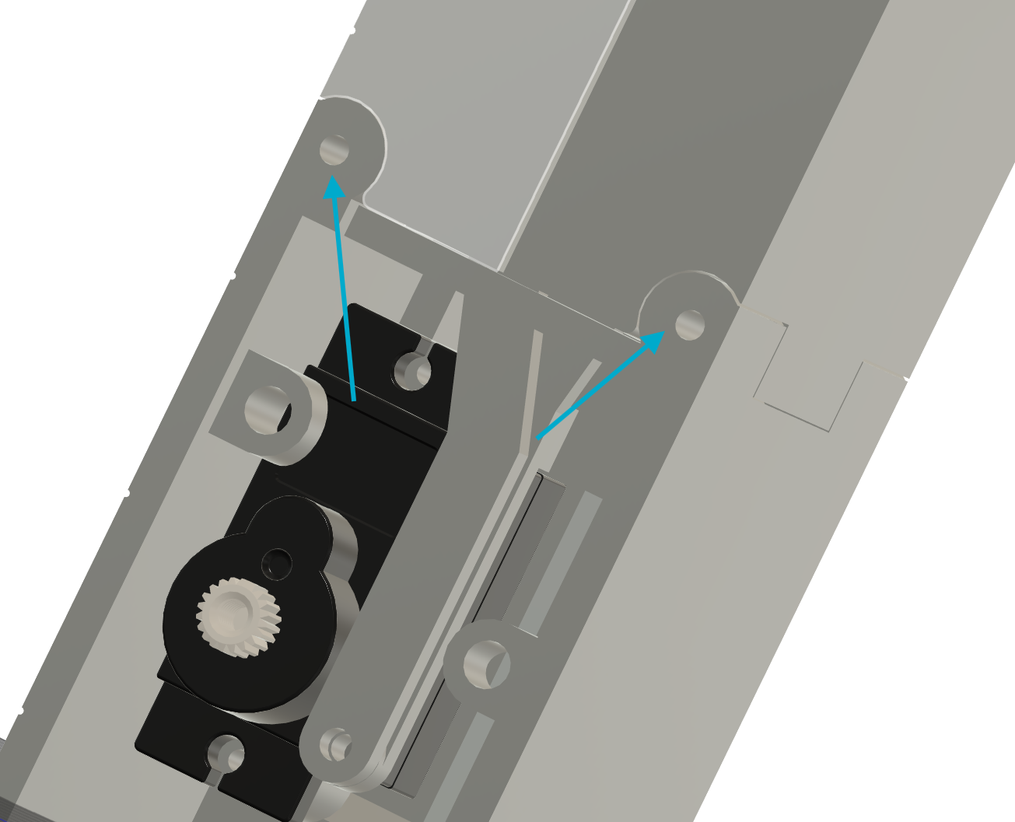

11. link the arm to the arm leg thing part, insert a length of filament through the hole indicated by the arrow to secure that arm and leg together.

12. Install the main arm MG996R servo in the arm leg thing part. Notice the orientation on this image. Make sure all the wires for the servo and buck converter go on one side of the servo.
Secure the servo to the arm leg thing par.

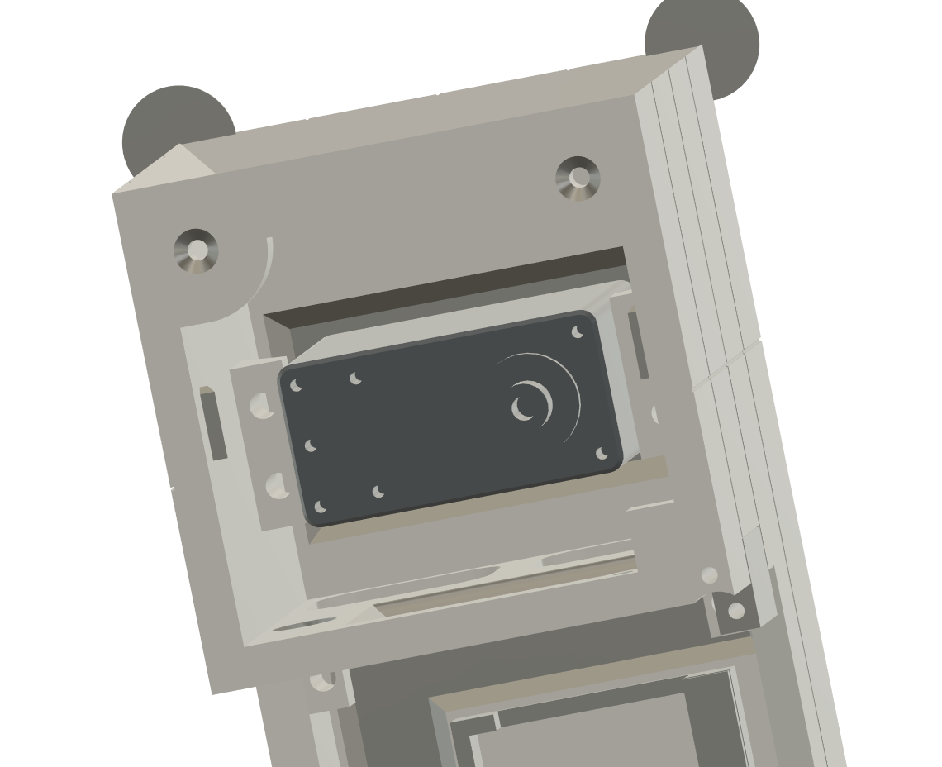

13. Insert heat inserts in the in the hole of the Bottom Adjustable Arm Shaft and the Top Adjustable Arm Shaft parts and screw in a m2.5 40mm screw to form a little shaft.
(There is also a printable version without heat inserts (Printable arm Shaft – Starboard printable arm shaft))

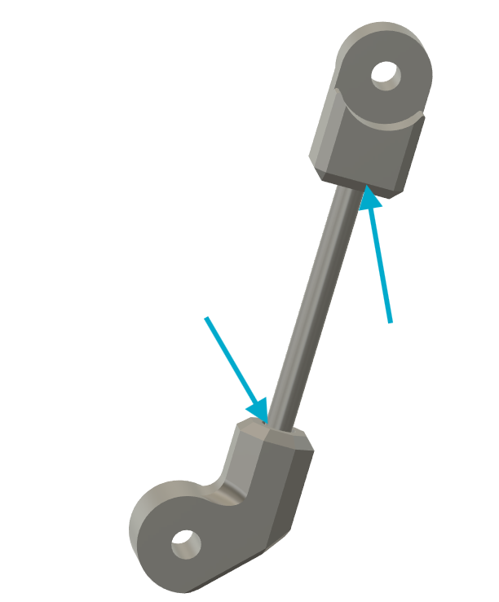

14. Connect all the servo to their respective extension wire.

15. If any of the servo were rotated by error, Run the V2_app_servotester.py app again to reset their positions to the presets.

16. connect the adjustable arm and connecting arm so that the arm is fully closed. Make sure the adjustable arm can swivel freely. The connecting arm needs to be tight on the servo.

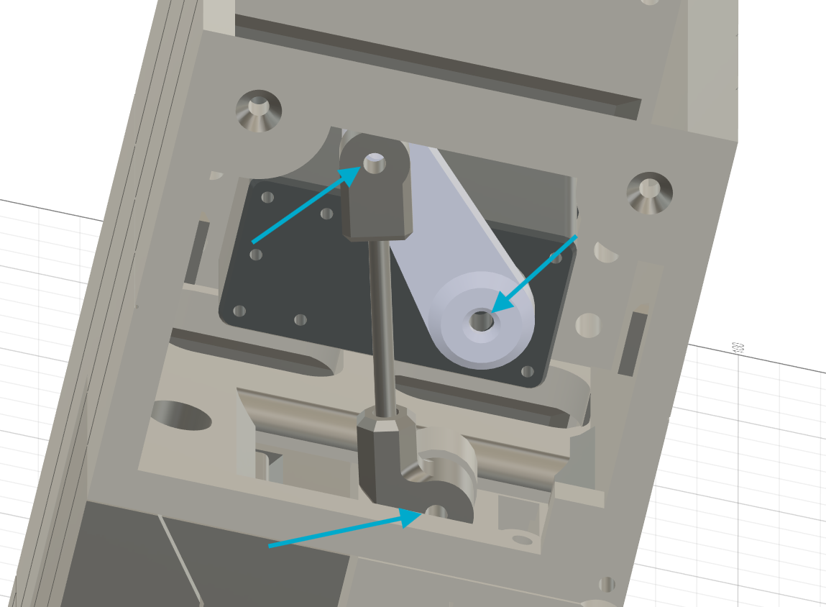

17. Connect the internal shaft to the servo and secure it with the screw that came with the servo. Use a self tapping m2 screw to secure the internal shaft to the finger 1 and 2 rods. Use the servo horn that came with the mg90s servo and position it like on the image. You can now bolt the forearm case lid and the main arm case lid down.

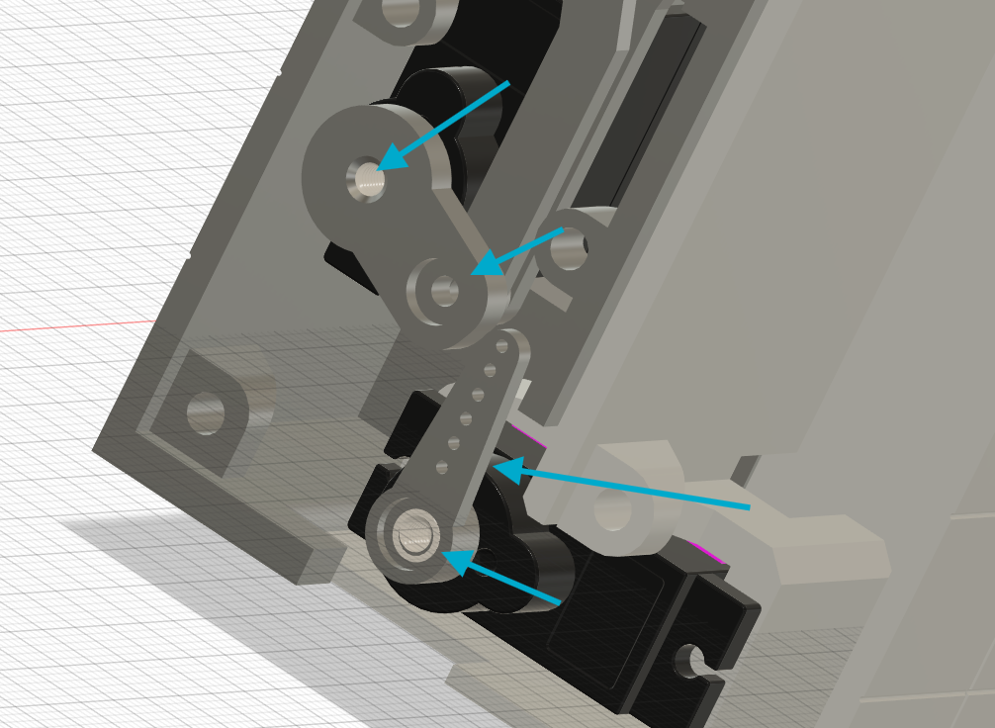

Final Assembly

1. Bolt the speakers to the Hull Lid part.

2. Feed the speaker wires with the rest of the other wires through the upper case hole.

3. Press the power switch through the access panel frame and run a length of filament to attach the access panel door, make sure the filament sits flush on each side.

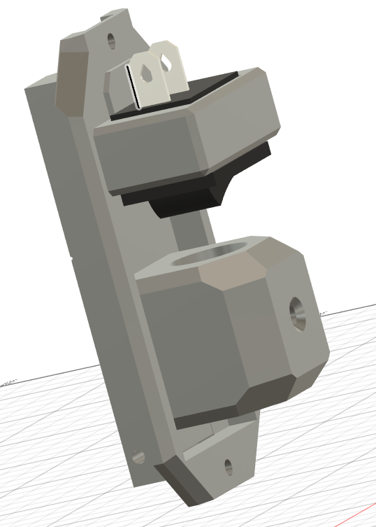

4. insert a magnet on the access panel frame and door so they are attracted to each other.

5. Attach the hull on the servo on each side.. it might be tricky a bit to feed the wires but normally the 18 gauge wires go in the center channel of the hull below the servo and all the other wires are just going around the servo. It helps to attach the wires with tie wrap to hold them together.

6. Bolt on the servo clip once you are sure no wires are pinched.

7. Put the lid on the hull part and connect the arm leg thing part to the hull.

8. Finalize the wiring using the provided diagram

9. Secure the raspberry pi using 2 m2.5 40mm screws, you might need to add a couple of spacers if they are too long.

10. Bold down the lower chassis base part along with the chassis foot pad to the lower chassis.

11. Bolt down the legs foot pad.

12. Secure the screen to the upper lid using the screen clips.

13. Use the velcro strips to secure the battery to the lower lid and insert the charging wire in the access panel door hole made for it.

14. Close down the lower and upper lid.

